**Sprint 6: Adding Features**

The feature that we implemented this week was the ability to add photos to an event when it is first created. This photo then appears in the main event page when users are looking through them. Here are some screenshots:  
  
**In this photo, you can see the ability to add photos by clicking the “Update” button at the bottom. Likewise, you can remove the photo by clicking the red X.**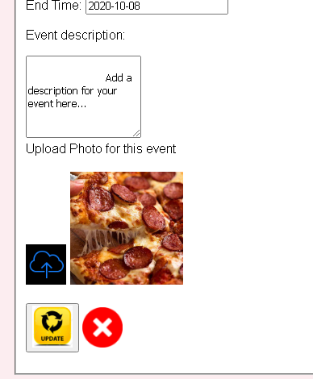

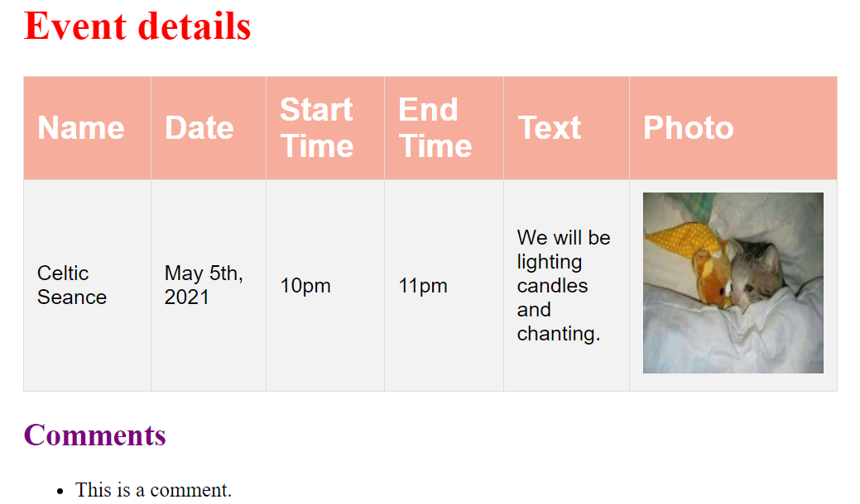

**This photo shows the event page and what an event with a picture would look like if it was being viewed by a user.**

**Dark / Light Switch feature:** This feature uses jQuery and Ajax to implement the appearance of each page.

When Dark Mode is not on:

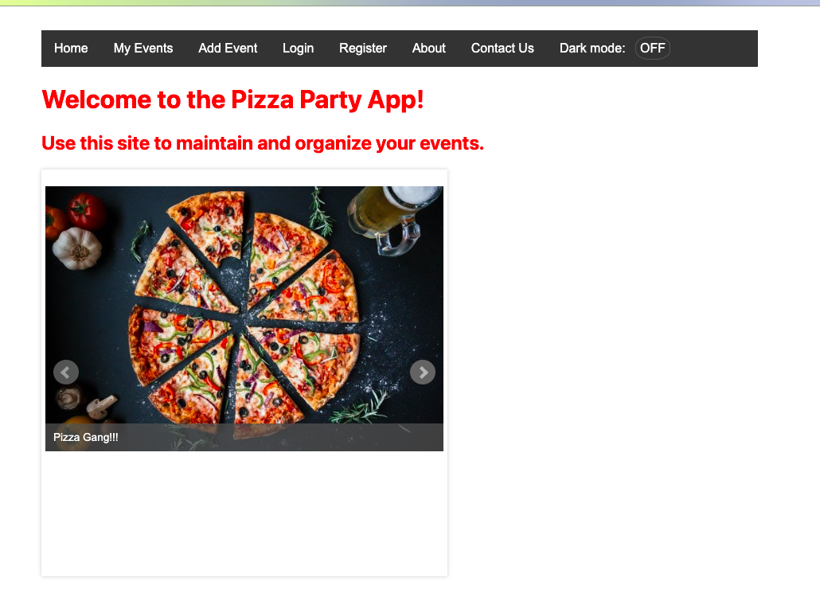

When Dark Mode is on:

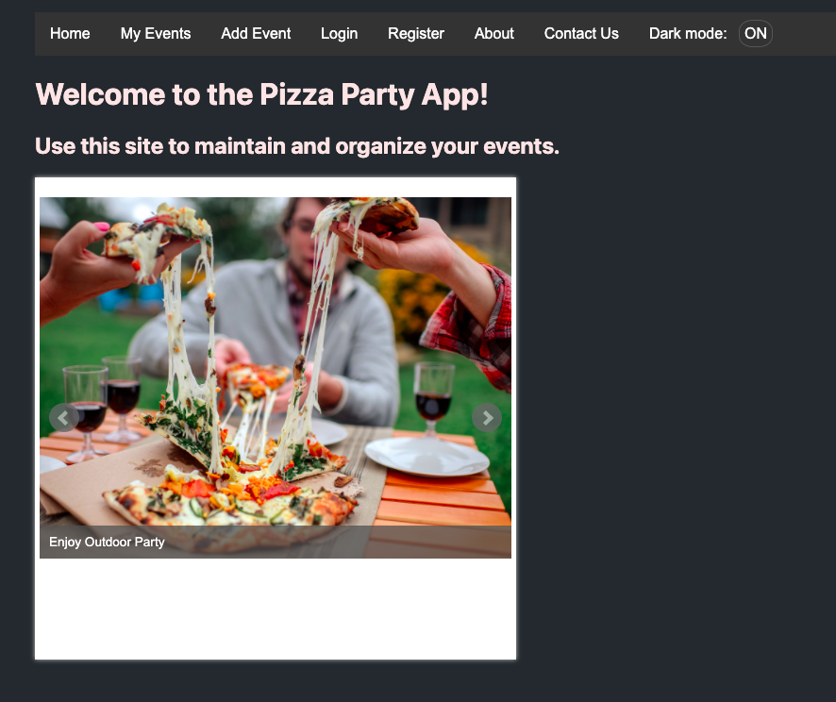

Product Backlog: <https://docs.google.com/document/d/1EDqXXR6pV_w66170z4fx4qHEpPm0uNQSvAYgb2PHuoY/edit>